**Professional**

Name:________________________________________ Date: _________________________

**Law Enforcement**



**Personal History Information**

**Rogers County Sheriff’s Office Scott Walton, Sheriff**

114 S. Missouri Ave.

Claremore, Oklahoma 74017

(918) 342-9700

*AN EQUAL OPPORTUNITY, DRUG-FREE WORKPLACE EMPLOYER*

**MISSION STATEMENT**

**Rogers County Sheriff’s Office**

***It is the mission of the Rogers County Sheriff’s Office to serve all people within out jurisdiction with respect, fairness, and compassion. We are committed to the protection of life and property; the preservation of peace, order, and safety; the vigorous enforcement of local, State, and Federal laws; and the defense of the Constitution of the State of Oklahoma and the Constitution of the United States of America in a fair and impartial manner.***

**Rogers County Sheriff’s Office**

The Rogers County Sheriff’s Office is located at 201 S. Cherokee, Claremore, Oklahoma. It is our mission to provide quality law enforcement, custodial and court related services to all persons in Rogers County. Law Enforcement is more than a job, it is a profession. Employees of the Rogers County Sheriff’s Office are dedicated to serving and helping the citizens of Rogers County. If helping others and community service are your goals, then a position with the Rogers County Sheriff’s Office may be for you. The application process for both full and part-time positions is multi-staged and is designed to recruit quality Sheriff’s Office employees.

**BASIC QUALIFICATIONS FOR DEPUTY SHERIFF:**

n Bilingual preferred but not required

n Are at least 21+ years of age

n Vision - Corrected distant vision 20/20 in each eye

n Are legally authorized to work in the USA

n Have a high school diploma, or GED

n Have a valid Oklahoma driver’s license and liability insurance

n Have no criminal charges pending

n Are not on probation for any criminal offense

n Have never been convicted of a felony

**DETENTION OFFICER QUALIFICATIONS:**

n Be 18 years of age

n Be legally authorized to work in the USA n Possess a High School Diploma or GED n Possess a valid Oklahoma driver’s license

n Have never been convicted of a felony, have criminal charges pending, or be on probation for any criminal

offense

n Currently have good vision-corrected distant vision 20/20 in each eye

ROGERS COUNTY SHERIFF'S OFFICE

201 S. Cherokee

Claremore, Oklahoma 74017

(918) 342-9797

AUTHORITY FOR RELEASE OF INFORMATION

Last Name

I

First Name

I Middle Name

I Sex I Race I

Date of Birth

Place of Birth (City/County)

State/Country

I I

Social Security Number *I* Driver's License

I, , do hereby authorize a review of and full disclosure of all records, or any part thereof as well as any verbal or electronic information , concerning myself, by and to any duly authorized agent of the Rogers County Sheriff 's Office, whether the said records are of public, private or confidential nature.

The intent of this authorization is to give my consent for full and complete disclosure of information relating to activities from individuals, schools, residential management agents, employers, criminal justice agencies, credit bureaus, consumer reporting agencies, collection agencies, retail business establishments or other sources of information. This information may include, but is not limited to my academic, residential, achievement, performance, attendance, disciplinary, criminal, civil and/or traffic history record information , financial and credit information and employment history , employment and pre-employment records, including background reports, efficiency ratings, complaints or grievances filed by or against me.

I reiterate, and emphasize that the intent of this authorization is to provide full and free access to the background and history of my personal life, for the specific purpose of pursuing a background investigation by the Rogers County Sheriff's Office for the purpose of making a determination of the suitability or eligibility for employment. It is my specific intent to provide access to personal information, however personal or confidential it may appear to be, and the sources of information specifically identified herein.

I understand that any information obtained by a personal history background investigation, which is developed directly or indirectly, in whole or in part, upon this release authorization will be considered in determining my suitability for employment by the Rogers County Sheriff’s Office. I understand that all materials pertaining to this background investigation become the property of the Rogers County Sheriff’s Office, Services Division, and will not be returned or revealed to me.

I agree to indemnity and hold harmless the Rogers County Sheriff 's Office and it's agent(s) as well as the person to whom this request is presented and his agents and employees from and against all claims, damages, losses and expenses, including reasonable attorney's fees, arising out of or by reason of complying with a request for information. I further understand that in the event my application is disapproved, the confidential information obtained and the sources of confidential information cannot be revealed to me.

A photocopy of this release form will be valid as an original hereof, even though the said photocopy does not contain an original writing of my signature. This authority of release of information shall remain in full force until revoked by me in writing.

MUST BE SIGNED IN THE PRESENCE OF A NOTARY

APPLICANT’S SIGNATUIRE

STREET ADDRESS

CITY

STATE

ZIP CODE

Subscribed and sworn before me this day of

, 20 .

My Commission Expires

, 20 .

Signature

The Rogers County Sheriff’s Office is An Equal Opportunity Employer

Revised 05/17/2018

**Professional Law Enforcement**

### Rogers County Sheriff’s Office Scott Walton, Sheriff

**Application Procedure**

1. The first step of the process begins by carefully and thoughtfully completing an application for employment. Attach a copy of your current driver’s license and social security card, birth certificate, and High School Diploma or GED. If you have served in the military, include a copy of your DD-214. College Degrees and or credit hours, although not required, must be submitted with official transcripts. Oklahoma Certified Pease Officers must provide a copy of their CLEET Training History along with a copy of their certification card. Applications are kept on file for 12 months. After 12 months, a new application must be submitted for consideration. In order to be eligible for testing, all documents should be included in the application before examination.
2. You will be notified in writing of the date and location of your pre-employment physical agility test. After taking the test you will be notified of your results and if you are eligible for further employment processing. Passing an examination does not guarantee employment. The names of successful candidates are considered for further processing as positions within the sheriff’s office become available.
3. Candidates failing any portion of the application process, with the exception of the background investigation, may repeat the process after a period of 30 days. If a candidate fails any portion of the application process a second time, that candidate may repeat the application process after one year from their initial application date.
4. Successful completion of the oral screening board will make a candidate eligible to continue in the application process with a thorough and in-depth background investigation that will be conducted before appointment to any position within the Sheriff’s Office. Candidates failing the background investigation are not eligible to repeat the application process.
5. After an offer of employment, you must successfully complete a physical, drug screening test, MMPI test, and any necessary training. Employees must reside in Rogers County within 60 days of employment unless a waiver is granted during that time.
6. The expected duration of the application process is three to six months.

Rogers County offers a generous benefit package for regular employees. The benefits are divided into contributory and non-contributory areas.

CONTRIBUTORY BENEFITS NON-CONTRIBUTORY BENEFITS

|  |  |  |  |
| --- | --- | --- | --- |
| 1. | Dental Insurance | 1. | Vacation |
| 2. | Medical Care Insurance | 2. | Holidays |
| 3. | Life Insurance | 3. | Personal/Sick Leave |
| 4. | Cancer Insurance | 4. | Jury Duty |
| 5. | Disability Insurance | 5. | Funeral Leave |
| 6. | Accidental Death & Dismemberment Insurance | 6. | Military Leave |
| 7. | Retirement | 7. | Voluntary Pre-Tax Benefit Plan |
| 8. | Parking |  |  |
| 9. | Credit Union |  |  |
| 10. | Education Reimbursement |  |  |
| 11. | FICA |  |  |
| 12. | Deferred Compensation |  |  |
| 13. | COBRA |  |  |
| 14. | Intensive Care |  |  |
| 15. | Vision Insurance |  |  |

**Rogers County Sheriff’s Office**

**ROGERS COUNTY SHERIFF**

201 S. Cherokee

Claremore, Oklahoma 74017

### BACKGROUND INVESTIGATION

**QUESTIONNAIRE Scott Walton**

SHERIFF

#### INSTRUCTIONS

READ AND FOLLOW ALL INSTRUCTIONS BELOW. FAILURE TO DO SO WILL DELAY OR VOID YOUR APPLICATION.

1. COMPLETE IN ***BLACK INK*, *LEGIBLY***. *PRINT IN YOUR OWN HANDWRITING.*

**2. ANSWER EACH QUESTION *COMPLETELY* AND *ACCURATELY*. *EACH BLANK MUST HAVE AN ANSWER IN IT.* IF THE QUESTION CALLS FOR A “NO” OR “NONE” ANSWER, BE SURE TO STATE IT. IF THE QUESTION DOES NOT APPLY TO YOU, WRITE “N/A” IN THE APPROPRIATE SPACE.**

1. IF THERE IS NOT ENOUGH SPACE ON THE FORM FOR YOU TO PROVIDE A COMPLETE ANSWER, ATTACH ADDITIONAL SHEETS. BE SURE TO LABEL ANY ATTACHED SHEETS CLEARLY WITH THE NUMBER OF THE QUESTION YOU ARE ANSWERING.
2. SIGN AND DATE THE QUESTIONNAIRE.
3. RETAIN A COPY OF THE QUESTIONNAIRE FOR YOUR RECORDS.
4. RETURN THE COMPLETE QUESTIONNAIRE AND OTHER REQUESTED INFORMATION TO:

Human Resources Department Rogers County Sheriff’s Office 201 S. Cherokee

**Claremore, Oklahoma 74017**

1. BE SURE TO SUBMIT AN OFFICIAL COLLEGE TRANSCRIPT, HIGH SCHOOL DIPLOMA OR OTHER APPROPRIATE PROOF OF EDUCATION AS SOON AS POSSIBLE TO THE HUMAN RESOURCES DEPARTMENT AT THE ADDRESS ABOVE IF YOU HAVE NOT ALREADY DONE SO.

#### REMEMBER

* + INCOMPLETE OR INACCURATE ANSWERS MAY BE GROUNDS FOR REJECTION OR REMOVAL.
  + WHETHER INTENTIONAL OR INADVERTENT, OMISSIONS ARE TAKEN VERY SERIOUSLY.
  + IT IS BETTER TO PROVIDE INFORMATION THAT IS UNNECESSARY THAN TO OMIT INFORMATION THAT MAY BE NECESSARY.
  + IT IS ALSO BETTER TO TELL THE TRUTH, NO MATTER WHAT. YOUR APPLICATION WILL BE GIVEN EVERY CONSIDERATION IN LIGHT OF ALL AVAILABLE INFORMATION.
  + YOUR APPLICATION WILL NOT BE CONSIDERED FURTHER UNTIL THIS FORM IS CORRECTLY COMPLETED AND SUBMITTED TO THE HUMAN RESOURCES DEPARTMENT.
  + YOU MAY BE ASKED TO SUBMIT ADDITIONAL INFORMATION OR DOCUMENTATION PERTAINING TO YOUR APPLICATION.
  + BE SURE TO NOTIFY THE HUMAN RESOURCES DEPARTMENT *IN WRITING* OF ANY CHANGES IN ADDRESS, TELEPHONE NUMBER, STATUS, OR ANY OTHER INFORMATION RELEVANT TO YOUR APPLICATION.

|  |  |  |  |  |  |  |  |  |  |  |  |  |  |  |  |
| --- | --- | --- | --- | --- | --- | --- | --- | --- | --- | --- | --- | --- | --- | --- | --- |
| **Date of Application** | | | **Position For Which You Are Applying** | | | | | | | | | | | | |
| Have you ever been employed by Rogers County? o Yes o No Dates: From: To: Position Held Do you have relatives employed with Rogers County? o Yes o No  If yes, who:  **I. IDENTIFICATION INFORMATION** | | | | | | | | | | | | | | | |
| Last Name | | | | | First Name | | | | | | | | | | Middle Name |
| List any other names you have used or been known by, including maiden name, and give reasons. (If none, so state.) | | | | | | | | | | | | | | | |
| Present Address (Street, City, County, State, and Zip Code) | | | | | | | | | | Apt. # | | | | Apartment Complex Name | |
| Home Phone Number | | | | | | Work Phone Number | | | | | | Cell Phone Number | | | |
| Date of Birth | | | | | | Are you over the age of 18? | | | | | Place of Birth | | | | |
| Race | | Sex | | Height | | | | Weight | Color/Hair | | | | Color/Eyes | | |
| S.S. # | | | | | | | Driver's License Number / State / Expiration Date | | | | | | | | |
| Do you now or have you ever possessed a driver's license issued by a state other than Oklahoma? o Yes o No If yes, enter name of state, type and number of licenses. | | | | | | | | | | | | | | | |
| Please list any scars, marks or tattoos. | | | | | | | | | | | | | | | |
| Are you a U.S. citizen? o Yes o No | | | | | | | Naturalization Certificate Number (If applicable, provide copy.) | | | | | | | | |
| Are you bilingual? o Yes o No If so, list languages: | | | | | | | | | | | | | | | |
|  | | | | | | | | | | | | | | | |
| **II. EDUCATION** | | | | | | | | | | | | | | | |
| 1. List chronologically (earliest date first) all high schools (9th grade), colleges and trade schools you have attended.  **Name of School From To G.P.A. Degree or Credit Address/City/State (Mo./Yr.) (Mo./Yr.) Hours Received**  High School: | | | | | | | | | | | | | | | |
|  |  | | | | | | | | | | | | | | |
| University or College: | | | | | | | | | | | | | | | |
|  |  | | | | | | | | | | | | | | |
| Vocational or Technical: | | | | | | | | | | | | | | | |
|  |  | | | | | | | | | | | | | | |
| **Submit a certified transcript for High School, College, Vocational and Technical Training.** | | | | | | | | | | | | | | | |

|  |  |  |  |  |  |
| --- | --- | --- | --- | --- | --- |
| **II. EDUCATION (Continued)** | | | | | |
| 2. Did you graduate from high school? G.E.D.? If yes, submit certified transcript and certificate or degree. | | | | | |
| GED: Yes No | | High School: Yes No | | | |
| 3. Other than English, are you conversationally fluent in any language(s)? If yes, which language(s)? | | | | | |
| 4. List any disciplinary actions you received in school.  Date School Problem Brief Explanation | | | | | |
| 5. List all awards and honors received while attending high school and/or college. | | | | | |
| 6. List any medical training (E.M.T., First Responder, etc.) | | | | | |
| 7. CLEET Certified Yes No If yes, provide a copy of certification. | | | | | |
| 8. List any other skills, abilities or experience you possess that you believe relevant to the position which you are applying. | | | | | |
| **III. EMPLOYMENT HISTORY** | | | | | |
| 1. List your employment activities, beginning with the present (#1) and working back 15 years. You should list all full-time work, part-time work, military service, temporary military duty to locations over 90 days, self-employment, other paid work, and all periods of unemployment. The entire 15-year period must be accounted for without breaks, but you need not list employments before your 18th birthday. Use additional pages if necessary,    1. **Employer (Company)** | | | | | |
| Name | | | | | |
| Address | | | | | |
| City | State | | | | Phone |
| Name of Supervisor | | | | | |
| Position Held | | | | | |
| Number of Hours Worked Weekly | | | | Ending Salary | |
| Date Employed: From | | | To: | | |
| Number of Employees You Supervised | | | | | |
| Reason for Leaving: Resigned | | Terminated | | | |
| Explain | | | | | |
| Description of Work, Specific Duties | | | | | |
| May we contact your current employer prior to job offer? o Yes o No  If no, explain | | | | | |

1. Employer (Company)

|  |  |  |  |  |  |
| --- | --- | --- | --- | --- | --- |
| Name | | | | | |
| Address | | | | | |
| City | State | | | | Phone |
| Name of Supervisor | | | | | |
| Position Held | | | | | |
| Number of Hours Worked Weekly | | | | Ending Salary | |
| Date Employed: From | | | To: | | |
| Number of Employees You Supervised | | | | | |
| Reason for Leaving: Resigned | | Terminated | | | |
| Explain | | | | | |
| Description of Work, Specific Duties | | | | | |
| May we contact this employer prior to job offer? o Yes o No If no, explain | | | | | |

1. **Employer (Company)**

|  |  |  |  |  |  |
| --- | --- | --- | --- | --- | --- |
| Name | | | | | |
| Address | | | | | |
| City | State | | | | Phone |
| Name of Supervisor | | | | | |
| Position Held | | | | | |
| Number of Hours Worked Weekly | | | | Ending Salary | |
| Date Employed: From | | | To: | | |
| Number of Employees You Supervised | | | | | |
| Reason for Leaving: Resigned | | Terminated | | | |
| Explain | | | | | |
| Description of Work, Specific Duties | | | | | |
| May we contact this employer prior to job offer? o Yes o No If no, explain | | | | | |

1. **Employer (Company)**

|  |  |  |  |  |  |
| --- | --- | --- | --- | --- | --- |
| Name | | | | | |
| Address | | | | | |
| City | State | | | | Phone |
| Name of Supervisor | | | | | |
| Position Held | | | | | |
| Number of Hours Worked Weekly | | | | Ending Salary | |
| Date Employed: From | | | To: | | |
| Number of Employees You Supervised | | | | | |
| Reason for Leaving: Resigned | | Terminated | | | |
| Explain | | | | | |
| Description of Work, Specific Duties | | | | | |
| May we contact this employer prior to job offer? o Yes o No If no, explain | | | | | |

1. **Employer (Company)**

|  |  |  |  |  |  |
| --- | --- | --- | --- | --- | --- |
| Name | | | | | |
| Address | | | | | |
| City | State | | | | Phone |
| Name of Supervisor | | | | | |
| Position Held | | | | | |
| Number of Hours Worked Weekly | | | | Ending Salary | |
| Date Employed: From | | | To: | | |
| Number of Employees You Supervised | | | | | |
| Reason for Leaving: Resigned | | Terminated | | | |
| Explain | | | | | |
| Description of Work, Specific Duties | | | | | |
| May we contact this current employer prior to job offer? o Yes o No  If no, explain | | | | | |

1. **Employer (Company)**

|  |  |  |  |  |  |
| --- | --- | --- | --- | --- | --- |
| Name | | | | | |
| Address | | | | | |
| City | State | | | | Phone |
| Name of Supervisor | | | | | |
| Position Held | | | | | |
| Number of Hours Worked Weekly | | | | Ending Salary | |
| Date Employed: From | | | To: | | |
| Number of Employees You Supervised | | | | | |
| Reason for Leaving: Resigned | | Terminated | | | |
| Explain | | | | | |
| Description of Work, Specific Duties | | | | | |
| May we contact this employer prior to job offer? o Yes o No If no, explain | | | | | |

1. **Employer (Company)**

|  |  |  |  |  |  |
| --- | --- | --- | --- | --- | --- |
| Name | | | | | |
| Address | | | | | |
| City | State | | | | Phone |
| Name of Supervisor | | | | | |
| Position Held | | | | | |
| Number of Hours Worked Weekly | | | | Ending Salary | |
| Date Employed: From | | | To: | | |
| Number of Employees You Supervised | | | | | |
| Reason for Leaving: Resigned | | Terminated | | | |
| Explain | | | | | |
| Description of Work, Specific Duties | | | | | |
| May we contact this employer prior to job offer? o Yes o No If no, explain | | | | | |

|  |  |  |  |  |  |  |
| --- | --- | --- | --- | --- | --- | --- |
| **J. EMPLOYMENT HISTORY (Continued)** | | | | | | |
| 1. Are you now engaged in any business as an owner/partner (silent or active), stockholder, or corporate member? If yes, give complete details. | | | | | | |
| 2. Do you possess any license or permit (excluding driver’s license) issued by a government agency? If yes, give complete details. | | | | | | |
| **V. FAMILY HISTORY** | | | | | | |
| List current spouse, parents, all brothers and sisters, including any step-relatives if applicable. (If deceased, please indicate.) | | | | | | |
| **1 .** Full Name | | Relationship | Date of Birth | | Address/Phone | |
| Employer | Employer Address | | | Phone | | Title |
| **2 .** Full Name | | Relationship | Date of Birth | | Address/Phone | |
| Employer | Employer Address | | | Phone | | Title |
| **3 .** Full Name | | Relationship | Date of Birth | | Address/Phone | |
| Employer | Employer Address | | | Phone | | Title |
| **4 .** Full Name | | Relationship | Date of Birth | | Address/Phone | |
| Employer | Employer Address | | | Phone | | Title |
| **5 .** Full Name | | Relationship | Date of Birth | | Address/Phone | |
| Employer | Employer Address | | | Phone | | Title |
| **6 .** Full Name | | Relationship | Date of Birth | | Address/Phone | |
| Employer | Employer Address | | | Phone | | Title |
| **7 .** Full Name | | Relationship | Date of Birth | | Address/Phone | |
| Employer | Employer Address | | | Phone | | Title |

|  |  |  |  |  |  |  |  |  |  |
| --- | --- | --- | --- | --- | --- | --- | --- | --- | --- |
| **V. FAMILY HISTORY (Continued)** | | | | | | | | | |
| List current spouse, parents, all brothers and sisters, including any step-relatives if applicable. (If deceased, please indicate.) | | | | | | | | | |
| **8 .** Full Name | | Relationship | Date of Birth | | | Address/Phone | | | |
| Employer | Employer Address | | | Phone | | | | Title | |
| **9 .** Full Name | | Relationship | Date of Birth | | | Address/Phone | | | |
| Employer | Employer Address | | | Phone | | | | Title | |
| 10**.** Full Name | | Relationship | Date of Birth | | | Address/Phone | | | |
| Employer | Employer Address | | | Phone | | | | Title | |
| **11.** Full Name | | Relationship | Date of Birth | | | Address/Phone | | | |
| Employer | Employer Address | | | Phone | | | | Title | |
| **12.** Full Name | | Relationship | Date of Birth | | | Address/Phone | | | |
| Employer | Employer Address | | | Phone | | | | Title | |
| **VI. SOCIAL ACQUAINTANCES** | | | | | | | | | |
| **PEOPLE WHO KNOW YOU WELL.**  List **3 people** who know you well and live in the United States. They should be good friends, peers, colleagues, college roommates, etc., whose combined association with you covers as well as possible the last 5 years. Do not list your spouse, former spouses, or other relatives, and try not to list anyone who is listed elsewhere on this form. | | | | | | | | | |
| **1**. Name | | | | | | | Race | | Sex |
| Street Address | | | | | | | | | |
| City | | | State | | Zip | | | | |
| Home Phone Number | | | Date of Birth | | | | | | |
| Employment | | | | | | | | | |
| Business Phone | | | Occupation | | | | | | |
| Business Address | | | | | | | | | |
| City | | | State | | Zip | | | | |

|  |  |  |  |  |
| --- | --- | --- | --- | --- |
| **VI. SOCIAL ACQUAINTANCES (Continued)** | | | | |
|  | | | | |
| **2.** Name | | | Race | Sex |
| Street Address | | | | |
| City | State | Zip | | |
| Home Phone Number | Date of Birth | | | |
| Employment | | | | |
| Business Phone | Occupation | | | |
| Business Address | | | | |
| City | State | Zip | | |
| **3.** Name | | | Race | Sex |
| Street Address | | | | |
| City | State | Zip | | |
| Home Phone Number | Date of Birth | | | |
| Employment | | | | |
| Business Phone | Occupation | | | |
| Business Address | | | | |
| City | State |  | | |

|  |  |  |  |  |  |
| --- | --- | --- | --- | --- | --- |
| **VII. REFERENCES** | | | | | |
| List three references (not relatives), not listed elsewhere, who are responsible adults of reputable standing in the community who have known you well for the past five years. If retired, give former occupation.  Your 3 letters of reference (signed and dated) are to be included with your personal history background booklet. Include phone numbers for contact. **Only one from the same company.** | | | | | |
| **A**. Name | | | | Race | Sex |
| Street Address | | | | | |
| City | State | | Zip | | |
| Home Phone Number | Date of Birth | | | | |
| Employment | | | | | |
| Business Phone | | Occupation | | | |
| Business Address | | | | | |
| City | | State | Zip | | |
|  | | | | | |
| **B**. Name | | | | Race | Sex |
| Street Address | | | | | |
| City | State | | Zip | | |
| Home Phone Number | Date of Birth | | | | |
| Employment | | | | | |
| Business Phone | | Occupation | | | |
| Business Address | | | | | |
| City | | State | Zip | | |
|  | | | | | |
| **C**. Name | | | | Race | Sex |
| Street Address | | | | | |
| City | | State | Zip | | |
| Home Phone Number | | Date of Birth | | | |
| Employment | | | | | |
| Business Phone | | Occupation | | | |
| Business Address | | | | | |
| City | | State | Zip | | |

|  |  |  |  |  |  |  |  |  |  |  |  |  |
| --- | --- | --- | --- | --- | --- | --- | --- | --- | --- | --- | --- | --- |
| **VIII. RESIDENCES (PAST AND PRESENT)** | | | | | | | | | | | | |
| **WHERE YOU HAVE LIVED**  List the places where you have lived, beginning with the most recent (#1) and working back 7 years. All periods must be accounted for in your list. Be sure to indicate the actual physical location of your residence: do not use a post office box as an address, do not list a permanent address when you were actually living at a school address, etc. Be sure to specify your location as closely as possible.  For any address in the last 5 years, list a person who knew you at that address, and who preferably still lives in that area (do not list people for residences completely outside this 5-year period, and do not list your spouse, former spouses, or other relatives). Also, for addresses in the last five years, if the address is “General Delivery,” a Rural or Star Route, or maybe difficult to locate, provide directions for locating the residence on an attached continuation sheet. | | | | | | | | | | | | |
| 1. Address | | | | City | | | | | State | | | Zip |
| Contact | | | | | | | | | | | Phone | |
| 2. Address | | | | City | | | | | State | | | Zip |
| Contact | | | | | | | | | | | Phone | |
| 3. Address | | | | City | | | | | State | | | Zip |
| Contact | | | | | | | | | | | Phone | |
| 4. Address | | | | City | | | | | State | | | Zip |
| Contact | | | | | | | | | | | Phone | |
| 5. Address | | | | City | | | | | State | | | Zip |
| Contact | | | | | | | | | | | Phone | |
| **IX. MARITAL INFORMATION** | | | | | | | | | | | | |
| 1. Check the appropriate marital status.  Single Married Engaged Separated Divorced Widowed | | | | | | | | | | | | |
| 2. Please provide the following information about **your spouse, fiancée**, **significant other or parent of any children** (include Spouse’s maiden name): | | | | | | | | | | | | |
| Last Name | | | | First | | | | | | | | Middle |
| Maiden Name | | | | | | | Date of Marriage | | | | | |
| Street Address | | | | | | | | | | | | |
| City | | | State | | | Zip | | | | | Phone | |
| Date of Birth | | | City & State of Birth | | | | | | | | | |
| Place of Employment | | | | | | | | | | | | |
| Business Address | | | | | | | | | | | | |
| City | | | | | State | | | Zip | | | | |
| 3. Please complete the following for **PREVIOUS SPOUSE(S)** if divorced, separated or widowed: | | | | | | | | | | | | |
| **1.** Last Name | | | | First | | | | | | | | Middle |
| Date of Birth | Date of Marriage | | | | | | | | | Date of Divorce | | |
| o Divorced o Separated o Annulled o Widowed | | | | | | | | | | | | |
| Street Address | | | | | | | | | | | | |
| City | | State | | | | Zip | | | | | Phone | |
| **2.** Last Name | | | | First Middle | | | | | | | | |
| Date of Birth | Date of Marriage | | | | | | | | | Date of Divorce | | |
| o Divorced o Separated o Annulled o Widowed | | | | | | | | | | | | |
| Street Address | | | | | | | | | | | | |
| City | | State | | | | Zip | | | | | Phone | |

|  |  |  |  |  |  |  |  |  |  |  |  |  |
| --- | --- | --- | --- | --- | --- | --- | --- | --- | --- | --- | --- | --- |
| **3.** Last Name | | | | First | | | | | | | Middle | |
| Date of Birth | | Date of Marriage | | | | | | Date of Divorce | | | | |
| o Divorced o Separated o Annulled o Widowed | | | | | | | | | | | | |
| Street Address | | | | | | | | | | | | |
| City | | State | | | | Zip | | | Phone | | | |
| **Provide copies of marriage certificates and divorce decrees. | | | | | | | | | | | | |
| 4. Have you ever been divorced or had a marriage annulled? Yes No If yes, provide copy of court decrees. | | | | | | | | | | | | |
| **X. CHILDREN AND DEPENDENTS** | | | | | | | | | | | | |
| 1. List all of your children (step-children/adopted) and give the following information.  Full Name Date of Birth Current Address Supported By | | | | | | | | | | | | |
|  |  | | | | | | | | | | | |
|  | | | | | | | | | | | |
|  | | | | | | | | | | | |
|  | | | | | | | | | | | |
|  | | | | | | | | | | | |
|  | | | | | | | | | | | |
| 2. List all occupants of your household not listed elsewhere in this book. | | | | | | | | | | | | |
| **1.** Full Name | | | | | Relationship | | | | | Date of Birth | | |
| Employer | | | Employer Address | | | | Phone | | | | | Title |
| **2.** Full Name | | | | | Relationship | | | | | Date of Birth | | |
| Employer | | | Employer Address | | | | Phone | | | | | Title |
| **3.** Full Name | | | | | Relationship | | | | | Date of Birth | | |
| Employer | | | Employer Address | | | | Phone | | | | | Title |
| **4.** Full Name Relationship | | | | | | | | | | Date of Birth | | |
| Employer | | | Employer Address | | | | Phone | | | | | Title |
| **5.** Full Name | | | | | Relationship | | | | | Date of Birth | | |
| Employer | | | Employer Address | | | | Phone | | | | | Title |

1. **MILITARY AND SELECTIVE SERVICE INFORMATION**
   1. If you are a male born after December 31, 1959, have you registered with the Selective Service? If yes, provide Selective Service Number.

(Selective Service Registration Information Office: 1-847-688-6888)

If no, please explain why.

* 1. Have you ever served in a military organization? o Yes o No

If, yes, provide the following information. Attach a copy of your DD214 long form with application. Branch of Service

Rank / Grade Type of Discharge

Organization / Station / Unit Unit Commanding Officer

* 1. Were you ever the subject of any formal disciplinary action in the military? o Yes o No If yes, please explain:

## FINANCIAL HISTORY INFORMATION

* 1. Have you ever filed bankruptcy? o Yes o No If yes, explain.
  2. Are you currently experiencing any difficulty meeting your normal living expenses? o Yes o No If yes, explain.
  3. List past due payments over 90 days including any delinquent loans over 180 days.
  4. Have you ever been delinquent with child support payments? o Yes o No If yes, explain.
  5. Have you ever had any property repossessed? o Yes o No If yes, explain.
  6. Have you or do you now have a garnishment against you? o Yes o No If yes, explain.
  7. Have you ever written a check that was referred for collection or prosecution? o Yes o No If yes, where?
  8. Have you ever been refused a bond? o Yes o No If yes, explain.
  9. Do you have income from any source other than your principal occupation? o Yes o No If yes, explain.
  10. List below any motor vehicle(s) that you own, rent/lease, or in which you hold an interest.

Year Make Model Color License Number/ Year of License

* 1. Are all vehicles referred to in #10 above insured? o Yes o No If no, explain.
  2. Have you ever had auto insurance canceled or have you been denied insurance? o Yes o No If yes, explain.

|  |  |  |  |  |
| --- | --- | --- | --- | --- |
| XII. FINANCIAL HISTORY INFORMATION (Continued) | | | | |
| 13. List the names and addresses of all individuals, companies, or others to whom you are indebted and the extent of your debts. Include rent, mortgages, vehicle payments, charge accounts, credit cards, loans, and any other debts or payments, and co/signed. | | | | |
| Type of Debt | | Name/ Address  of Creditor | Current  Balance | Monthly  Payment |
|  |  |  |  |  |
|  |  |  |  |
|  |  |  |  |
|  |  |  |  |
|  |  |  |  |
| XIII. CRIMINAL INFORMATION | | | | |
| Answer all of the following questions completely and accurately. ANY FALSIFICATION OR MISSTATEMENT OF FACT MAY BE SUFFICIENT TO DISQUALIFY YOU OR RESULT IN YOUR DISMISSAL.  All Applicants: Mark ''Yes" or "No" to all questions below.  1. 0 YES O NO Do you currently consume alcoholic beverages? If yes, to what extent?   1. 0 YES O NO Do you use tobacco products? If yes, to what extent? 2. O YES O NO Have you ever possessed or used illegal drugs? If yes, list substance possessed or used and number of times possessed or used. 3. O YES O NO Have you been charged with a crime of a deferred or suspended sentence, deferred or suspend prosecution (in this state or another state or pursuant to federal authority) for the commission of a felony? If yes, explain: 4. O YES O NO Have you had a protective or restraining order filed against you, or have any action pending? If so, where and when? 5. O YES O NO Do you or have you had any actions in a court of law (civil or criminal)? If yes, explain: | | | | |

## XIII. CRIMINAL INFORMATION (Continued)

* + 1. o YES o NO Have you ever been investigated, detained, arrested or convicted for any Domestic Violence/Child Abuse/Child Neglect related crime? If yes, explain:
    2. o YES o NO Have you ever been in or affiliated with any street gang or organized criminal group? If yes, explain:
    3. o YES o NO Have you ever been fingerprinted? If yes, explain:
    4. o YES o NO Have you ever been a victim of a crime? If yes, explain:
    5. o YES o NO Would your personal experience with drugs (or with friends or relatives who use drugs) affect your ability to enforce laws against them? If yes, explain:
    6. o YES o NO Have you ever filed for a protective or restraining order(s)? If yes, provide the name of the defendant, their address, phone number, employer and a copy of the order:
    7. o YES o NO Have you ever applied for a permit to carry a concealed weapon? If yes, what was the date of the application? Was the request granted? o Yes o No

Name of the Law Enforcement Agency applied to: Please explain the purpose for carrying the concealed weapon (also attach a copy of your permit):

|  |  |  |  |  |
| --- | --- | --- | --- | --- |
| **Date** | **Violation** | **Location** | **Court Disposition** | **Police Agency** |
|  |  |  |  |  |
|  |  |  |  |  |
|  |  |  |  |  |
|  |  |  |  |  |

|  |  |  |  |  |  |  |  |
| --- | --- | --- | --- | --- | --- | --- | --- |
| **Full Name** | **Race** | **Sex** | **Date of Birth** | **SSN** | **Relation** | **Crime** | **Arresting Agency** |
|  |  |  |  |  |  |  |  |
|  |  |  |  |  |  |  |  |
|  |  |  |  |  |  |  |  |
|  |  |  |  |  |  |  |  |

|  |
| --- |
| **XIII. CRIMINAL INFORMATION (Continued)** |
| 1. o YES o NO Have you ever stolen or taken without permission, anything from anyone? If yes, explain: 2. o YES o NO Have you ever been arrested or received a criminal citation and/or convicted of a crime? If yes, give details below. (Include all court documents. |
| 1. Have you ever been reported as a runaway or missing person? o YES o NO If yes, explain: 2. List below any member of your immediate family, friends, significant others, past and present that have ever been arrested for or convicted of a serious crime? |
| **XIV. GENERAL INFORMATION** |
| 1. Do you object to wearing a uniform? o YES o NO 2. Do you object to working:    1. Different shifts? o YES o NO B. Weekends? o YES o NO C. Holidays? o YES o NO   If yes to any of the above, explain. |

**XIV. GENERAL INFORMATION (Continued)**

1. Do you have any religious or moral beliefs that would prevent you from:
   1. Carrying a weapon? o YES o NO
   2. Taking a human life if necessary? o YES o NO
   3. Receiving medical treatment? o YES o NO
2. Have you previously applied for employment with the Rogers County Sheriff's Office? o YES o NO If yes, give approximate date.
3. Have you ever made application with any law enforcement agency other than the Rogers County Sheriff's Office?

o YES o NO If yes, complete the following.

|  |  |  |
| --- | --- | --- |
| Date | Agency | If not accepted, |
|  | Address/Phone | state reason |

1. Have you ever, by word of mouth or in writing, advocated, advised, or subscribed to the doctrine that the government of the United States of America, or any state or political subdivision thereof, should be overthrown or overturned by force, violence, or any unlawful means? o YES o NO
2. Are you now, or have since 18 years of age, ever been a member of any club, society, or organization? o YES o NO If yes, complete the following.

Name of Organization Address Position From To

(Mo./Yr.) (Mo./Yr.)

1. Have you ever been a party to a CIVIL action or proceeding anywhere, or have you been named in a notice of claim that you may be a defendant in a CIVIL action or proceeding? o YES o NO

If yes, list below every CIVIL action or proceeding (except divorce/annulments previously noted).

Date Location Action or Plaintiff, Defendant, Court Proceeding Petitioner or Disposition

Respondent

1. List all hobbies / pastimes / clubs you participate in regularly.

|  |  |  |  |  |  |  |  |  |
| --- | --- | --- | --- | --- | --- | --- | --- | --- |
| **IV. DRIVING INFORMATION** | | | | | | | | |
| 1. Has your operator's license ever been suspended or revoked? o YES o NO If yes, complete the following: | | | | | | | | |
| Suspended or Revoked | | Date | Location | | | Reason for Suspension or Revocation | | |
|  | |  |  | | |  | | |
|  | |  |  | | |  | | |
| 2. Have you ever been refused an operator's license by any state? o YES o NO If yes, give state and reason: | | | | | | | | |
| 3. Provide the following information for all traffic tickets you have ever received. Attach additional page if necessary. | | | | | | | | |
| Approx.  Date | Location | | | Police  Agency | Violation | | Disposition | |
|  |  | | |  |  | |  | |
|  |  | | |  |  | |  | |
|  |  | | |  |  | |  | |
|  |  | | |  |  | |  | |
|  |  | | |  |  | |  | |
| 4. Provide the following information for all traffic accidents in which you have been involved in last 10 years. | | | | | | | | |
| Date | Location | | | Police Agency | Nature of Violation or Cause of Accident | | | Were You At Fault? |
|  |  | | |  |  | | |  |
|  |  | | |  |  | | |  |
|  |  | | |  |  | | |  |
|  |  | | |  |  | | |  |
|  |  | | |  |  | | |  |
|  | | | | | | | | |

|  |
| --- |
| **XV. NARRATIVE** |
| In your handwriting, write a statement of why you are seeking employment with the Rogers County Sheriff's Office. Do not attach additional pages. (minimum of a paragraph) |
| **XVI. READ & SIGN THE FOLLOWING STATEMENT:** |
| I hereby certify that all statements made in this questionnaire are true, complete, and correct to the best of my knowledge and belief, and are made in good faith. I understand that any false information, misstatement or omission of material fact may disqualify me or result in my dismissal.    Signature (First, Middle and Last Name) Date |

**PHYSICAL ABILITY TEST COMPONENTS AND LAYOUT**

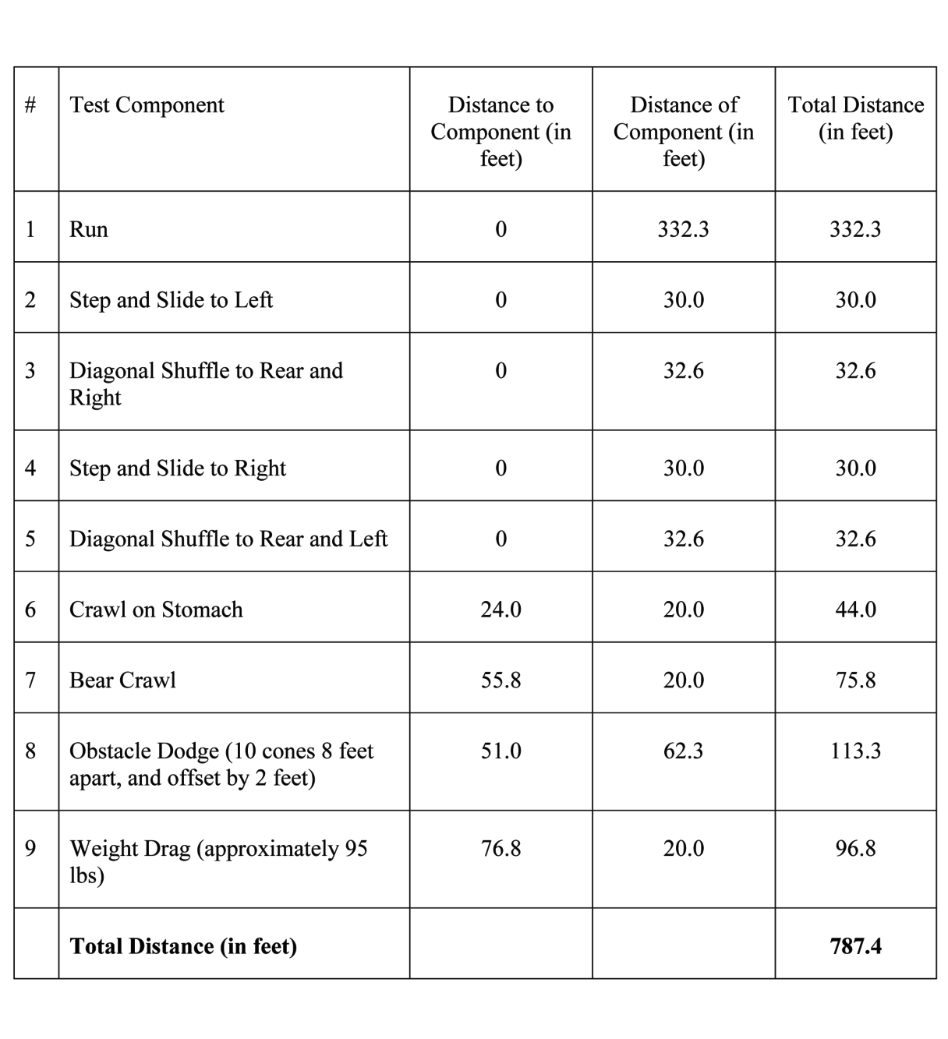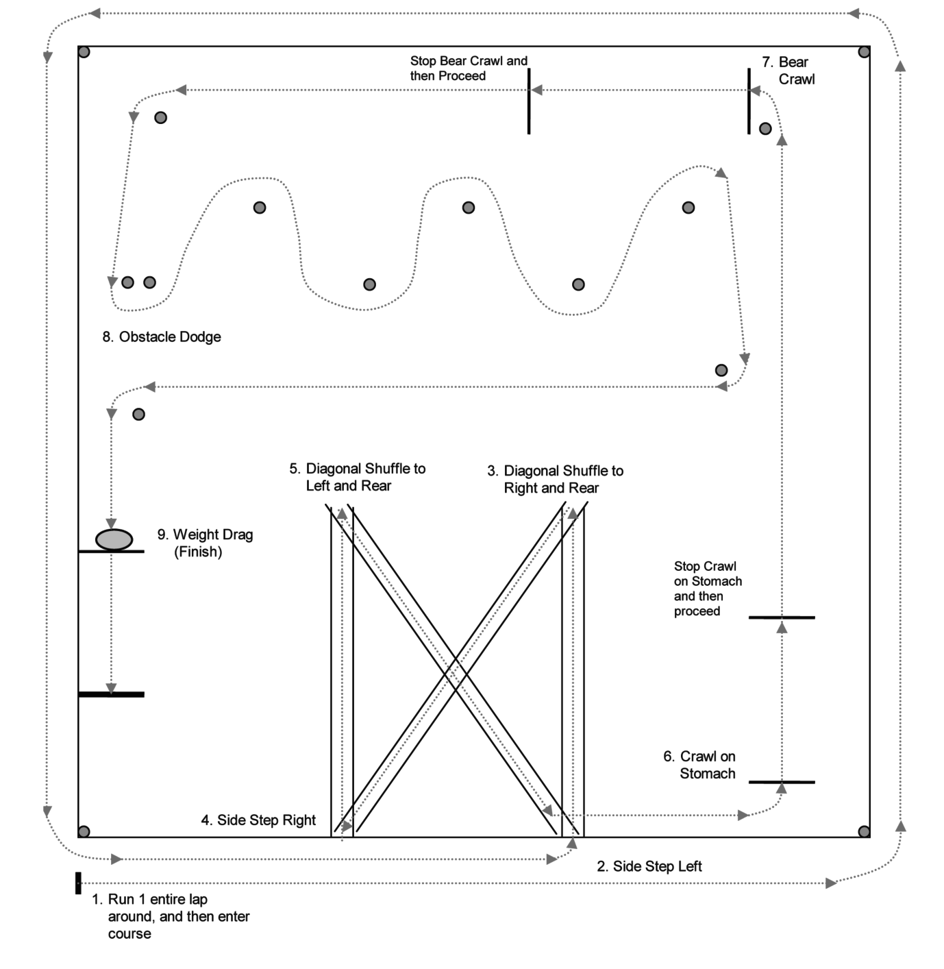

**FOR DEPUTY AND DETENTION OFFICER APPLICANTS ONLY**

MAP IS NOT DRAWN TO SCALE



**Commission on Accreditation for Law Enforcement Agencies**

Accreditation embodies the precepts of community oriented policing. It creates a forum in which police and citizens work together to prevent and control crime. This partnership helps citizens understand the challenges confronting law enforcement and gives law enforcement clear direction about community expectations.

Through Accreditation, the Rogers County Sheriff’s Office is able to bridge the gap between the agency and the community, better enabling the agency to fulfill its mission:

***It is the mission of the Rogers County Sheriff’s Office to serve all people within out jurisdiction with respect, fairness, and compassion. We are committed to the protection of life and property; the preservation of peace, order, and safety; the vigorous enforcement of local, State, and Federal laws; and the defense of the Constitution of the State of Oklahoma and the Constitution of the United States of America in a fair and impartial manner.***

Form 4212 (Rev. 1-15)